גיאומטריה חישובית 2

תרגיל 2

Swept Surfaces

מגיש: אליאס קואינקה 015257231

Program Description

The program reads and displays swept surfaces (reading a 2D profile and a 3D sweeping b-spline curve; uniform and non-uniform b-splines are supported) from the following file format:

# Profile (2D)
# Degree (Order - 1)
4
# Number of control points
5
# The knot vector (order + num.ctrl.points)
0,0,0,0.20,0.40,0.60,0.80,1,1,1
# The control points (x,y)
-100.0 -30.0
20.0 30.0
40.0 50.0
60.0 70.0
80.0 -25.0
# Sweep (a cubic b-spline) (3D)
# Number of control points
5
# The knot vector
0,0,0,0.25,0.5,0.75,1,1,1
# The control points (x,y,z)
-100.0 -30.0 10.0
20.0 30.0 12.0
40.0 20.0 20.0
60.0 70.0 -10.0
80.0 25.0 -30.0

Comments can be added with the # prefix and the program will ignore them when reading the file.

The program first calculates the two b-splines (profile and sweep) using the Cox-deBoor recursion. Sweep is always of third degree, while the profile degree is determined from the user selection in the file.

Next, the derivative is calculated along the sweep spline in order to calculate the local coordinate system along it. This is done according to the following formula:
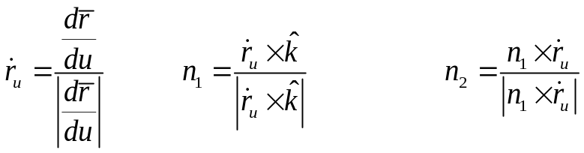
where u is the parameter along the sweep line.

The next step is rotating and translating the profile for each u in order to build the surface. So the general form is:
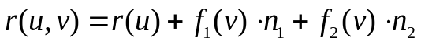
where f₁ and f₂ are the x and y components of the profile, respectively.
The program allows to change the knot vector of the profile (which simply recalculates the profile using the changed vector) or inserting new knots, which uses the Oslo algorithm to calculate the new control points and preserve the shape of the curve. Note that only insertion in the 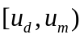range is allowed, where d is the degree, and m is the number of control points.

There is also an option to increase the degree of the profile curve. The restriction here is that the curve must be clamped, otherwise the curve will not stay the same.

The image can be zoomed by clicking and dragging with the right mouse button, and translated by clicking and dragging with the middle mouse button. The left mouse button allows for rotation. The button labeled Center Image returns to the original view. There's also a button to change the view from wireframe to solid model.

The program was written in Visual C++ with the OpenGL and MFC libraries.
Screenshots
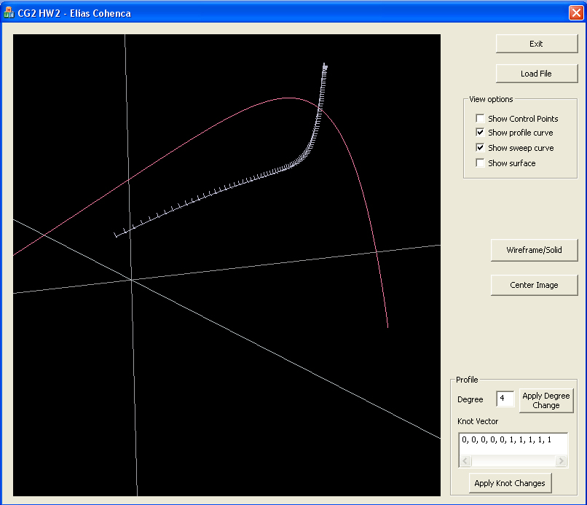

Selects what to display

Here we can see the profile curve and sweep curve (which also shows the local coordinate system at each u)

Change view from wireframe to solid

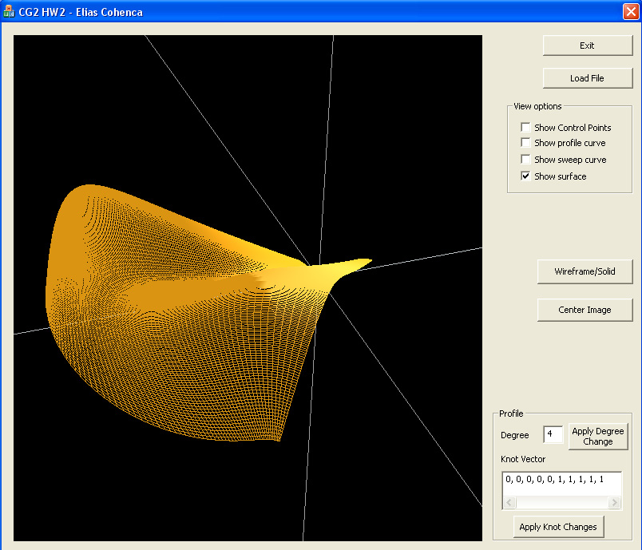
Here we can see and change the degree and knot vector
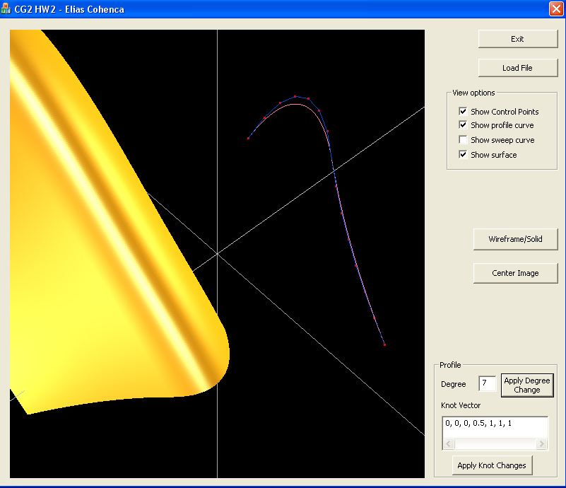
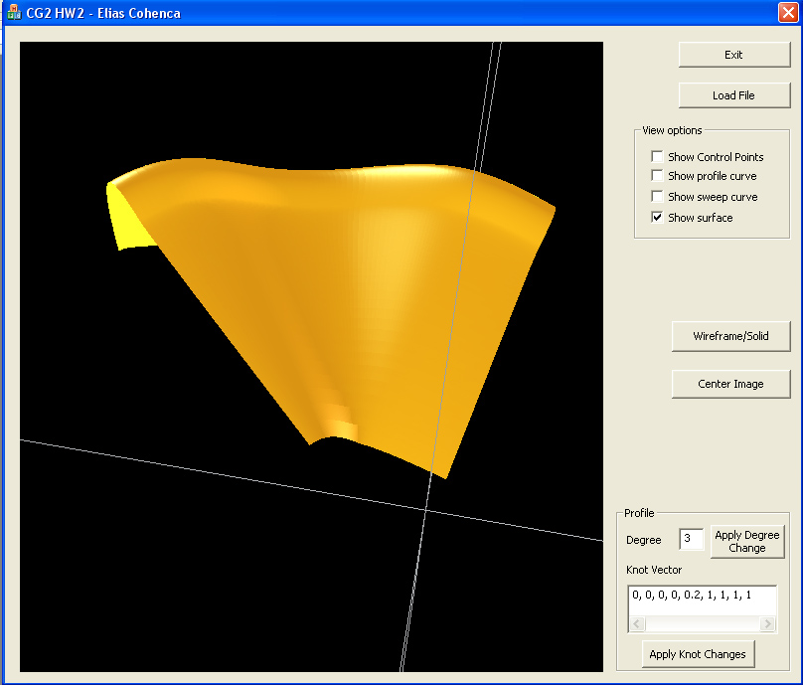
Here the degree was elevated from 3 to 7. We can see the control polygon approaching the b-spline

